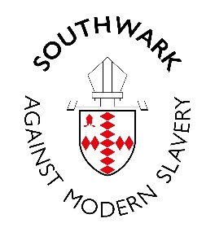
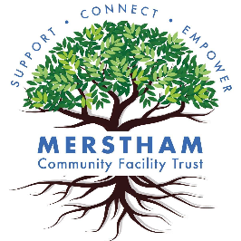MODERN SLAVERY
RIGHT HERE, RIGHT NOW

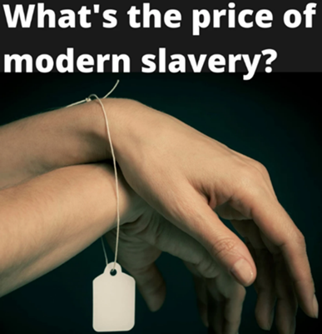
Do you know that
- Victims of slavery are living and working in our community here in Merstham?
- You see them
- You can change their lives

Come and find out more
on Friday 21st November, 2.15 – 4.30 p.m.
in the Oak Room, Merstham Community Hub, Portland Drive, RH1 3HY

Join with other Merstham volunteers to learn more about modern slavery as we listen to experts, hear real life stories and discuss what we may be able to do as a community to recognize and help people who may be entrapped

Contact lauren.ashley-boyall@mcft.org.uk or 07719191175
for more information

