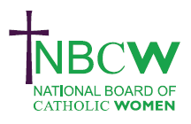
OCTOBER 2025 News from your Diocesan Link
JUBILEE 2025
CAFOD Family Fast Day October 3rd
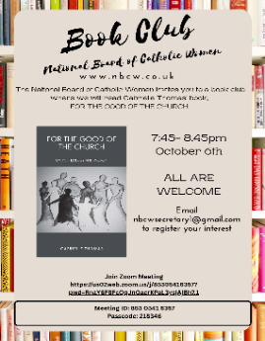 | October 6th 7.45-8.45 pm BOOK CLUB The NBC W invites you to a book club where we will read Gabrielle Thomas’s book For the Good of the Church. She looks at the concept of Receptive ecumenism and how it can help churches.Do join us for this introductory session to introduce ourselves, decide future meeting dates and process and hear about the author . Please email admin@NBCW.co.uk to register.

Tuesday 7th October at 7pm Fruits of the Synod - In conversation with Sr Marie Kolbe Zamora. Please join us on Zoom as we talk to Sr Marie Kolbe Zamora about her work during the Synod on behalf of Catholic Women around the world. This event will have a particular focus on how we can realise the fruits of the synod and how to grow them.
Please email admin@NBCW.co.uk to register

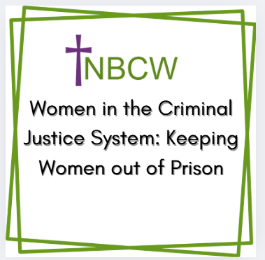 | 15 October from 7 – 8:30 pm Women in the Criminal Justice System: Keeping Women out of Prison. Zoom webinar chaired by Bishop Richard Moth, Liaison Bishops for Prisons, and will feature leading experts in this field Emily Evison of the Prison Reform Trust and Julia Corcoran of the Prison Advice and Care Trust (PACT).Register at: nbcw.co.uk/event/keeping-women-out-of-prison/
FOCUS on the NBCW
Each Month I will share the work of one of the committees of the NBCW. Perhaps you have skills that could help their work, or it is an area you are particularly interested in, if so do contact them to see what future opportunities there are. The Social Responsibility Committee of the NBCW is one of the three advocacy committees in the National Board of Catholic Women. For details of their work see Sue’s Church Page blog for October
_________________________________________________________________________________________________
REMINDERS: ABRAHAM COURSE Contact: Felicity Hadley email storrington@chemin-neuf.org or More details: https://www.chemin-euf.org.uk/abraham/
___________________________________________________________________________________
'Pathways to Implementation' Saturday 18th October 11:00am - 1:30pm via Zoom
Join our online interactive event exploring the next steps of the synod journey together at the grassroots level. https://www.schoolforsynodality.org.uk/events/pathways-for-implementation-next-steps-on-our-synod-journey
_________________________________________________________________________
To share your parish/organisation’s news or further info on the above please contact Sue Petritz nbcw@abdiocese.org.uk Diocesan Link for Arundel & Brighton or see https://sueschurchpage.blogspot.com/ copy/ click October web newsletter
The strength to persevere, the courage to speak out, the faith to believe.' Sr Joan Chittister OSB

