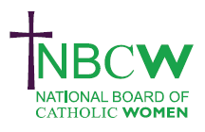 | JUNE 2023 Parish News from your Diocesan Link
SYNOD NATIONAL RESPONSE – THIRST for FORMATION?
38. ‘The thirst for formation is a striking and constant feature of almost every synod submission, suggesting at least that those who took part in the synod are offering themselves for mission and asking for permission and the means to carry it out.
39. They desire formation in Church teaching, Spirituality and Scripture, as well as practical tools and skills to enable discipleship: missions, retreats, adult catechesis, spiritual formation, and so on.’ National Synthesis Document 22nd June 2022 CBCEW
Do YOU have a yearning to know how to be equipped to evangelise and share the good news of Mission?
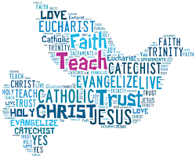 | Perhaps you have a diploma, degree or higher, or embarked on specific courses, or have practical experience of running parish groups or ministries. The NSD spoke of the thirst for formation and the NBCW would like to help to feed that thirst.  So please let me know what skills you have, and what skills you want to learn and then work together with the NBCW to meet/supply some of the formation.
Better still come to a Diocesan morning to have a chat over coffee.

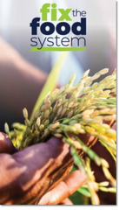 | Bishop Richard has signed The Cafod Letter to Fix the Food System. Look out for your chance to add your signature, in your parish! | 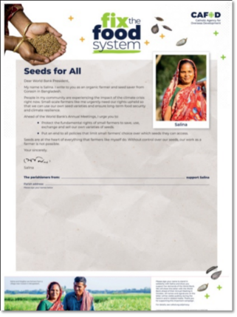

For further details of any of the above, or to share your projects, ideas and hopes for women of our Diocese, or if you would like information on resources please contact:-
Sue Petritz nbcw@abdiocese.org.uk
Diocesan Link for Arundel & Brighton
Actively promoting the presence, participation & responsibilities of Catholic Women

