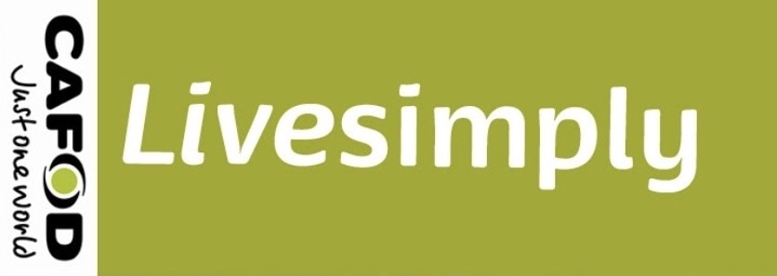

Can we be a Live Simply Award Parish?

The Live Simply Award is an opportunity for Catholic communities to respond to Pope Francis’ invitation in Laudato Si to “work with generosity and tenderness in protecting this world which God entrusted to us”

The Live Simply Award is earned by communities which show how they have been living

* Simply
* In solidarity with people in poverty
* Sustainably with creation

It celebrates what we have already done and will inspire us to do more. It will help us to live, not just more simply, but also more fully.

Father Tony has submitted a plan on behalf of the parish which comprises our application for the award. In the plan three main actions have been outlined which all involve smaller actions.

Every member of the parish, of all ages, can be involved on a personal and/or communal basis.

The main actions are:

* Practical Action support for the Faridpur plastic pollution project, which inspires us to be aware of our own plastic usage and efforts to reduce it.
* Laudato Si Initiative – care for the community, work for refugees, support of food banks, improvement of our environment, Fairtrade.
* CAFOD support – Fast Days and collections, Fix the Food System.

When we are ready CAFOD will organise two assessors to visit the parish to hear about what we have been doing and to celebrate our achievements .

