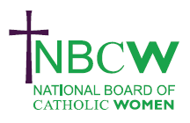
OCTOBER 2024 News from your Diocesan Link

CHILD POVERTY: CHALLENGES and SOLUTIONS . Please join the nbcw Social Responsibility Committee on Wednesday 9th October at 6.30pm in preparation for Challenge Poverty Week: a webinar featuring guest speakers: Ana Maria Bonny Hernandez (Beijing+30); Wendi Momen (Wilmette Institute); Margaret Clark (SVP); and Emma Revie (Trussell Trust). Contact nbcwsecretary1@gmail.com
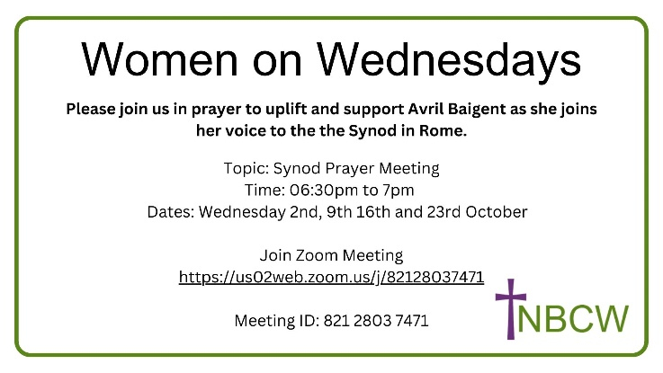

Saturday October 12th 11-12.30 pm See, Acknowledge, Remember: Reading Female Subjectivity in Ancient Jewish texts. Pia Regensburger will examine the roles women play in Old Testament and other Jewish writings. Her aim is to open a dialogue to examine within the webinar how wo/men can productively engage in critical readings of the Bible as a community. www.nbcw.co.uk, or email nbcwsecretary1@gmail.com

LIGHTHOUSE A&B CDSC Event - Saturday 12th October 2pm – 5pm at St Joseph's Church Epsom in Surrey. https://www.abcharismatic.org/lighthouse-october-12th-2024/

Light of Truth: Live Catholic Formation for Everyone from Dominican Sisters of St Joseph. With Light of Truth, we hope to share with everyone the fruits of our contemplation: the fruit of our prayer, of our academic formation and of our rich experience of working with adults, catechists and young people at the services of parishes and dioceses in the last 25 years. https://www.lightoftruth.uk/

To share your parish/organisation’s news or further info on the above please contact Sue Petritz nbcw@abdiocese.org.uk Diocesan Link for Arundel & Brighton
The strength to persevere, the courage to speak out, the faith to believe.' Sr Joan Chittister OSB

