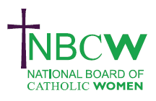
AUGUST 2024 News from your Diocesan Link

SYNODALITY 101: Conversations in the Spirit a series of online workshops
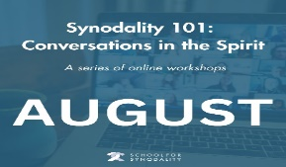
Workshop series to introduce the principles of holding prayerful, truthful and safe conversations which value gracious listening and courageous speaking. It is suitable for all levels of experience including people who have not been involved in the Synod process so far. admin@schoolforsynodality.org.uk

8, 15 22nd 2pm-4pm
Register HERE >>

October 5th 11-1pm. Inspiring Women 3rd webinar organised by The Women in the Church Committee: Title: I am Baptised, Called and Beloved: Living your baptismal calling to the full Webinar with the opportunity to discuss in parish groups or break out rooms Finishing with a closing liturgy of sending out. nbcwsecretary1@gmail.com.
https://www.godwhospeaks.uk/ for lots of scripture resources for August.
aN0RiL0Z4N2lDTGdHZz09Meeting ID: 842
Worth a read: Instrumentum Laboris ss.13-18
16. Concrete requests emerge from the contributions of the Episcopal Conferences for consideration at the Second Session,
including: (a) the promotion of domains for dialogue in the Church so that women can share their experiences, charisms, skills, and spiritual, theological and pastoral insights for the good of the whole Church;
(b) a wider participation of women in the processes of ecclesial discernment and all stages of decision-making processes (drafting and decision-making);
c) wider access to positions of responsibility in Dioceses and ecclesiastical nstitutions, in line with existing provisions.
https://press.vatican.va/content/salastampa/en/bollettino/pubblico/2024/07/09/240709d.html

On Saturday 13 th July 2024, A&B Merstham Foundation of Union of Catholic Mothers celebrated their 60th Anniversary at St. Teresa’s Church. Please see www.NBCW.co.uk for report and photos.

To share your parish/organisation’s news please contact Sue Petritz nbcw@abdiocese.org.uk Diocesan Link for Arundel & Brighton
The strength to persevere, the courage to speak out, the faith to believe.' Sr Joan Chittister OSB

