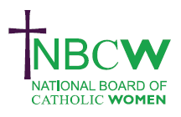
FEBRUARY 2024 News from your Diocesan Link
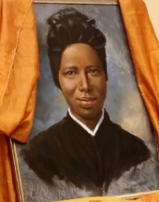
NBCW are looking for a Catholic woman with superhero admin IT skills to support the leadership, manage emails, zoom and publicity: part-time £15 per hr. Interviews are on 9th February. For full details see https://www.nbcw.co.uk/news

Celebration of St. Bakhita Day, 8th February, International Day of Prayer and against Human Trafficking.

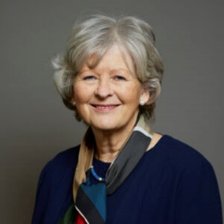
8 February @ 7:30 pm - 8:30 pm Catholic Union President Baroness Hollis who took over as President in November 2023, will be introducing herself to members and supporters of the Catholic Union in a webinar. The webinar will give people across the country the opportunity to meet our new President and to ask questions. The event is free but people do need to register in advance on Eventbrite to receive the link.

DOMESTIC VIOLENCE
16th February 12 noon – 1pm RESTORED. Hear their vision of a network of churches equipped to responding well to disclosures of domestic abuse so that those who are subjected to it can find a place of welcoming community. https://restored.cademy.co.uk/becoming-a-beacon-of-hope-restored-beacons
Safe in Faith is a project of Caritas Westminster. They are running free and low cost workshops on domestic abuse, trauma and faith throughout the year, starting in March.
12th March NBCW's VAWG committee, along with CSAN's Domestic Abuse Alliance
are hosting a webinar to launch Safe in Faith's signposting toolkit and the Faith and VAWG Coalition's guidance for Faith Leaders responding to domestic abuse.

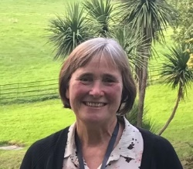
INSPIRING WOMEN: Women and Synodality SATURDAY 16TH MARCH, 2024 11.00am- 12.45pm. Avril Baigent and Helen Burgess will explore the synodal journey and encounter the voice of women. Helen is the lead Chaplain at the University of Bedfordshire. Avril is co-director of the School for Synodality and the pastoral ministry advisor and synod co-lead for the Diocese of Northampton. Join as individuals or a Parish group. For zoom link please contact nbcw@abdiocese.org.uk
To share your parish/organisation’s news please contact Sue Petritz nbcw@abdiocese.org.uk Diocesan Link for Arundel & Brighton
Actively promoting the presence, participation & responsibilities of Catholic Women

