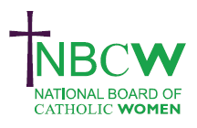 |  |  |  | DECEMBER 2023 News from your Diocesan Link
 | 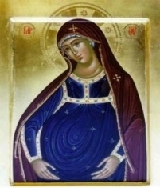 | NBCW WEBINAR Thursday 7th December 7.30-9.00pm. Preparing ourselves for Christmas, retired teacher of Theology, Jacintha Bowe, will give a short talk followed by an Ignatian style mediation on Mary and her Gifts.  For details see NBCW website www.nbcw.co.uk/events

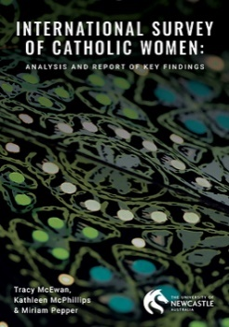
The International Survey of Catholic Women (ISCW) was commissioned by Catholic Women Speak to prepare a submission to the Synod of Bishops as part of the Synod 2021-2024 consultative process initiated by Pope Francis. It is one of the most extensive surveys of its kind ever undertaken. It is a significant and unique resource in its aim to listen to diverse voices to better discern what it means to “journey together” as the People of God in a Church of many cultures. https://www.catholicwomenspeak.com/cws-international-survey

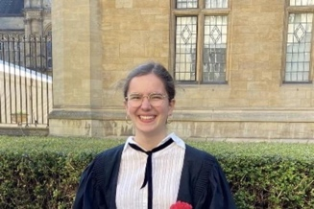 | NBCW WEBINAR Saturday 20th January 2024 11.00am - 12.30pm. Showcasing our Young Aspiring Theologians, Oxford Graduate in Theology, Pia Regensburger, will speak about the virtue of Hope in a lecture entitled ‘Hopelessly Hoping: The Experience of Hope in the Present-Day: Philosophical &Theological Explorations.”  For details see NBCW website www.nbcw.co.uk/events
SynodWatch RoundUP SYNOD WATCH ROUNDUP Synod Synthesis Offers Signs of Hope for New Inclusive Processes in the Church; An Urgent Call for Women’s Inclusion in Governance and Ministry. https://www.futurechurch.org/synod-watch/
THE GOD WHO SPEAKS Scripture resource. Inspiration and resources for the season of Advent can be found on https://www.godwhospeaks.uk/advent/

INVITED our Diocesan Resource for Advent can be downloaded at www.abdiocese.org.uk/invited
To Share your News please contact:-
Sue Petritz nbcw@abdiocese.org.uk Diocesan Link for Arundel & Brighton
Actively promoting the presence, participation & responsibilities of Catholic Women

