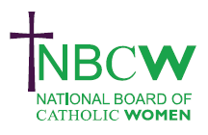 |  | NOVEMBER 2023 News from your Diocesan Link
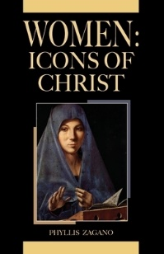 | Women in the Church Book Club will meet on Wednesday November 15th 7.30 - 9pm for spiritual discussion of Ch 1. Our NEW Book is Phyllis Zagano Women: Icons of Christ. For zoom link and accompanying workbook please contact nbcw@abdiocese.org.uk
INSPIRING WOMEN  Enabling Women to flourish in the Church  SATURDAY 25TH NOVEMBER, 2023 The National Board of Catholic Women invites you to a WEBINAR 11.00am- 12.45pm. Join as individuals or a Parish group  PROFESSOR TINA BEATTIE will explore how we can express our creativity and share our gifts as women; encourage and support women's many different abilities and callings; celebrate our achievements, and learn from our frustrations and failings. For zoom link please contact nbcw@abdiocese.org.uk |  |  | 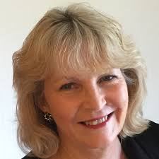

November 25th International day for elimination of violence against women. The VAWG committee (Violence Against Women and Girls) in conjunction with CSAN DA Alliance will be launching a calendar of actions for the 16 days of activism commencing 25th November. (link not yet available)

SOME RESOURCES
If you like to meditate on art see October 23 article from the World Union of Catholic Women’s Organisations https://www.wucwo.org/index.php/en/art-meditation

Synod Spiritual reflection from Fr Timothy Radcliffe as delivered at the Synod. Also meditations from the Synod retreat in Rome available on YouTube .https://www.vaticannews.va/en/vatican-city/news/2023-10/synod-spiritual-reflection-by-fr-timothy-radcliffe-at-16th-gc.html https://youtu.be/TGNIcerqhHE?si=cTlTrOHxiPO-ltQp

The School for Synodality is running weekly webinars mondays at 7.30pm. These can be viewed online via
https://www.schoolforsynodality.org.uk/practising-synodality-webinars https://www.schoolforsynodality.org.uk/practising-synodality-webinars
If you want to hear 2 priests speaking of the best and the worst of starting a Synodal diocese then watch episode 3: it’s great!. https://www.youtube.com/watch?v=-Nr3CBQ4Ehs

Sue Petritz nbcw@abdiocese.org.uk Diocesan Link for Arundel & Brighton
Actively promoting the presence, participation & responsibilities of Catholic Women

