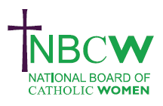 | SEPTEMBER 2023 News from your Diocesan Link

Craigmyle Lecture 2023 13 September @ 6:00 pm - 8:30 pm
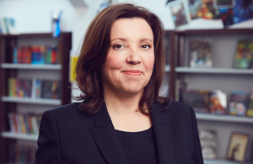 | The Catholic Union’s 2023 Craigmyle Lecture will be given by Dame Rachel de Souza DBE, the Children’s Commissioner for England who will talk about creating a society where children can flourish. In person or live streamed. https://catholicunion.org.uk/eventslist/craigmyle-lecture-2023/

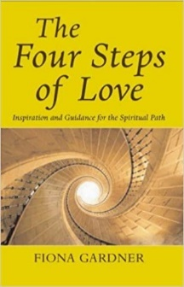 | Women in the Church Book Club will meet on Wednesday September 20th 7.30 - 9pm for spiritual discussion: looking at pp.70-90. For zoom link please contact nbcw@abdiocese.org.uk

INSPIRING WOMEN  Enabling Women to flourish in the Church  SATURDAY 25TH NOVEMBER, 2023 The National Board of Catholic Women invites you to a WEBINAR 11.00am- 12.45pm. Join as individuals or a Parish group  PROFESSOR TINA BEATTIE will explore how we can express our creativity and share our gifts as women; encourage and support women's many different abilities and callings; celebrate our achievements, and learn from our frustrations and failings. | 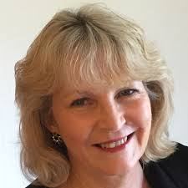

For further details of any of the above, or to share your projects, ideas and hopes contact
Sue Petritz nbcw@abdiocese.org.uk Diocesan Link for Arundel & Brighton
Actively promoting the presence, participation & responsibilities of Catholic Women

