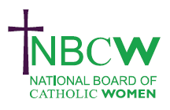 | OCTOBER 2023 News from your Diocesan Link
As the Synod first session gets under way there is a lot to get involved with.
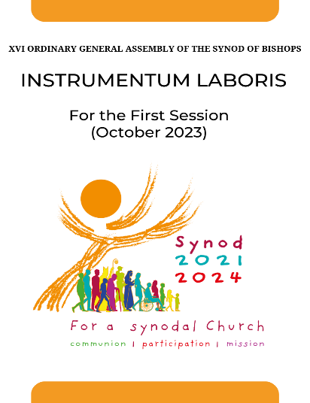 | September 30th Ecumenical prayer vigil in Rome. 5pm-7pm Rome time!  Do read the Catholic Herald https://catholicherald.co.uk/octobers-synod-in-rome-will-have-an-impact-far-beyond-the-church/  54 women invited to attend and vote in the Synod. This is a momentous time.  The Practicalities of Synodality: a webinar series running now on Mondays with speakers including Dr Jessie Rogers, Prof Anna Rowlands and Sr Ngozie Frances. https://www.schoolforsynodality.org.uk/news/practicing-synodality-webinar-series Recordings will be available afterwards.  WUCWO-WWO ‘Walking with the Synod’ on zoom , October 12, 19, & 26th.

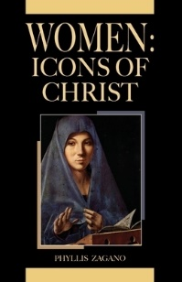 | Women in the Church Book Club will meet on Wednesday October 18th 7.30 - 9pm for spiritual discussion. Our NEW Book is Phyllis Zagano Women: Icons of Christ. For zoom link and accompanying workbook please contact nbcw@abdiocese.org.uk

INSPIRING WOMEN  Enabling Women to flourish in the Church  SATURDAY 25TH NOVEMBER, 2023 The National Board of Catholic Women invites you to a WEBINAR 11.00am- 12.45pm. Join as individuals or a Parish group  PROFESSOR TINA BEATTIE will explore how we can express our creativity and share our gifts as women; encourage and support women's many different abilities and callings; celebrate our achievements, and learn from our frustrations and failings. | 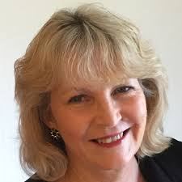
IF YOU HAVE EVENTS YOU WOULD LIKE TO SHARE , DO CONTACT:
Sue Petritz nbcw@abdiocese.org.uk Diocesan Link for Arundel & Brighton
Actively promoting the presence, participation & responsibilities of Catholic Women

