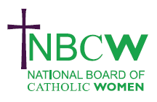 | AUGUST 2023 News from your Diocesan Link
Radio Maria England has sent a message: wishing all a lovely and safe August! Don’t forget that you can listen to Radio Maria England wherever you are in the world on the Radio Maria Play App - do take us with you wherever you go! (download by Google Play or Apple)

Craigmyle Lecture 2023 13 September @ 6:00 pm - 8:30 pm
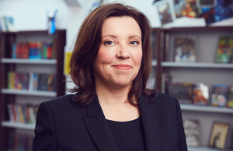 | The Catholic Union’s 2023 Craigmyle Lecture will be given by Dame Rachel de Souza DBE, the Children’s Commissioner for England who will talk about creating a society where children can flourish. In person or live streamed. https://catholicunion.org.uk/eventslist/craigmyle-lecture-2023/

Save the Date. 25th November 2023 11-12:30
INSPIRING WOMEN. Women in the Church Committee (NBCW) have arranged 3 further webinars, the first will be led by Prof. Tina Beattie who will explore ‘Enabling women to flourish in the Church.

A Resource suggestion
A Beautiful Thing Podcast with Angela Ward
The first series of ‘The 12 women of the gospel’ finished on the 21st June. Listen to stories of the Gospel told through storytelling and the arts @ https://www.a-beautiful-thing.co.uk/

For further details of any of the above, or to share your projects, ideas and hopes contact
Sue Petritz nbcw@abdiocese.org.uk Diocesan Link for Arundel & Brighton
Actively promoting the presence, participation & responsibilities of Catholic Women

