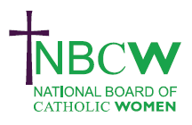
MAY 2023 Parish News from your Diocesan Link
EVENTS

May 15th 2023 18:30 – 20.00. Catholic Education in the 21st Century Britain webinar by Catholic Union. Our panel of speakers will consider some of the opportunities and challenges for Catholic schools in this country with opportunity for discussion and Q&A. Registration via Eventbrite

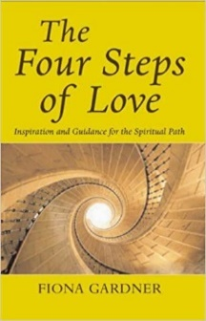 | Women in the Church book club will meet for the second session on Wednesday June 7th 7.30 - 9pm to discuss Fiona Gardner’s book. For relevant pages and zoom link please contact nbcw@abdiocese.org.uk

17th June 2023 NBCW Board Meeting in person meeting at at Romero House, 55 Westminster Bridge road, London SE1 7JB 10.30am registration with 11am start until 4pm https://www.eventbrite.com/e/nbcw-in-person-june-board-meeting-tickets-621730722327

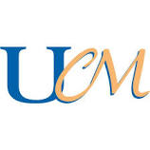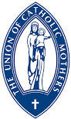 | I attended the Diocesan AGM for the Union of Catholic Mothers ‘UCM’ on 22nd April and heard of a host of in person Study, Social and Faith events and initiatives run by different Foundations (branches}. Open to all women the UCM is ready to welcome new members. For more information contact the Secretary Judy Harkins 01424 442018. (members at National Pilgrimage in Walsingham)
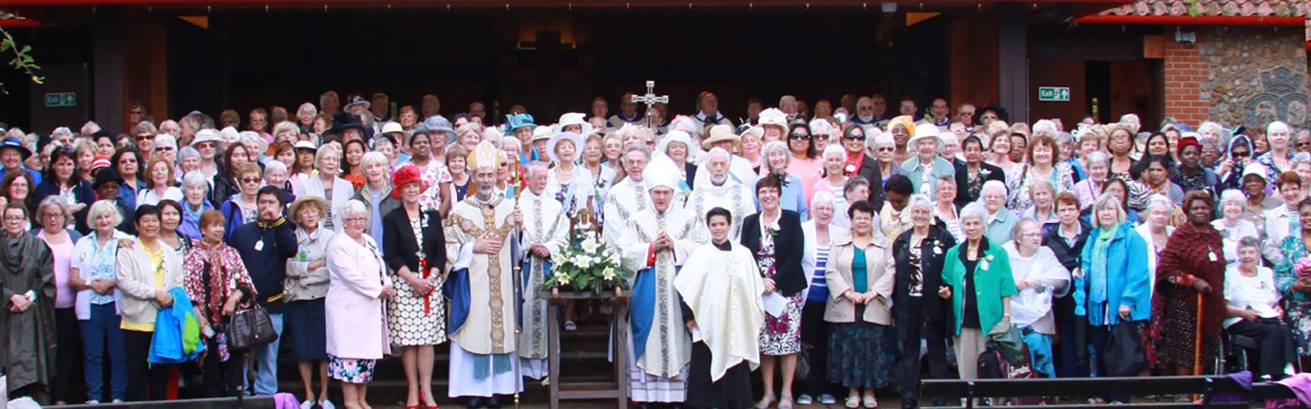
For further details of any of the above, or to share your projects, ideas and hopes for women of our Diocese, or if you would like information on resources please contact:- Sue Petritz nbcw@abdiocese.org.uk
Diocesan Link for Arundel & Brighton
Actively promoting the presence, participation & responsibilities of Catholic Women

